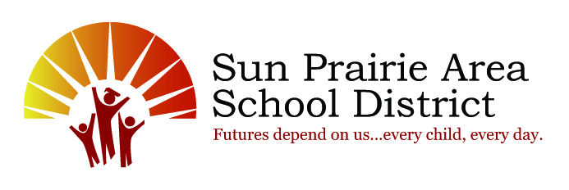

School Year Calendar At-A-Glance
2020-2021
2020
Tuesday September 1 First Day of School for Students (K-12)–FULL DAY
Monday September 7 No School-Labor Day
Tuesday September 8 First Day of School for 4K Students
Friday October 9 No School-Staff Professional Development
Friday October 30 No School
Monday November 2 End of the 1st Quarter
Thursday November 5 Family/Teacher Conferences 4:00 – 8:00 p.m.
- No School for 4K Students
Friday November 6 No School-Family/Teacher Conferences 7:00 – 11:30 a.m.
Wednesday November 25 No School
Thursday November 26 No School-Thanksgiving
Friday November 27 No School
Thursday December 24 No School-First Day of Winter Break
2021
Monday January 4 First Day Back from Winter Break
Monday January 18 No School-Martin Luther King Jr. Day
Tuesday January 19 Cardinal Heights Upper Middle School & High School Semester Exams
Wednesday January 20 Cardinal Heights Upper Middle School & High School Semester Exams
Thursday January 21 Cardinal Heights Upper Middle School & High School Semester Exams
Thursday January 21 End of the 2nd Quarter/1st Semester
Friday January 22 No School-Staff Professional Development
Friday February 26 No School-Staff Professional Development
Thursday March 11 Family/Teacher Conferences 4:00 – 8:00 p.m.
- No School for 4K Students
Friday March 12 No School-Family/Teacher Conferences 7:00 – 11:30 a.m.
Monday March 22 First Day of Spring Break
Monday March 29 First Day Back from Spring Break
Friday April 2 No School-Staff Professional Development
Monday April 5 End of 3rd Quarter
Friday May 28 No School-Staff Professional Development
Monday May 31 No School-Memorial Day
Friday June 4 Last Day of School for 4K Students
Tuesday June 8 Cardinal Heights Upper Middle School & High School Semester Exams
Wednesday June 9 Cardinal Heights Upper Middle School & High School Semester Exams
Thursday June 10 Cardinal Heights Upper Middle School & High School Semester Exams
Thursday June 10 End of 4th Quarter/2nd Semester
Last Day of School for Students in Grades K-12
- Elementary Dismissal at 11:45 a.m.
- Middle School Dismissal at 11:25 a.m.
- Cardinal Heights Upper Middle Dismissal at 11:35 a.m.
- High School Dismissal times based on Finals
Friday June 11 High School Graduation

* * * * * * * * * * * * * * * * * * * * * * * * * * * * * * * * * * * * * * * *
We have three weather days built into this schedule that we will not need to makeup should we have weather or other reasons for closing. If we have more than three, here is the plan:
Makeup # 1, or the fourth day: February 26, 2021 Makeup #2, or the fifth day: April 2, 2021
Makeup #3, or the sixth day: Add instructional minutes to the school day

