

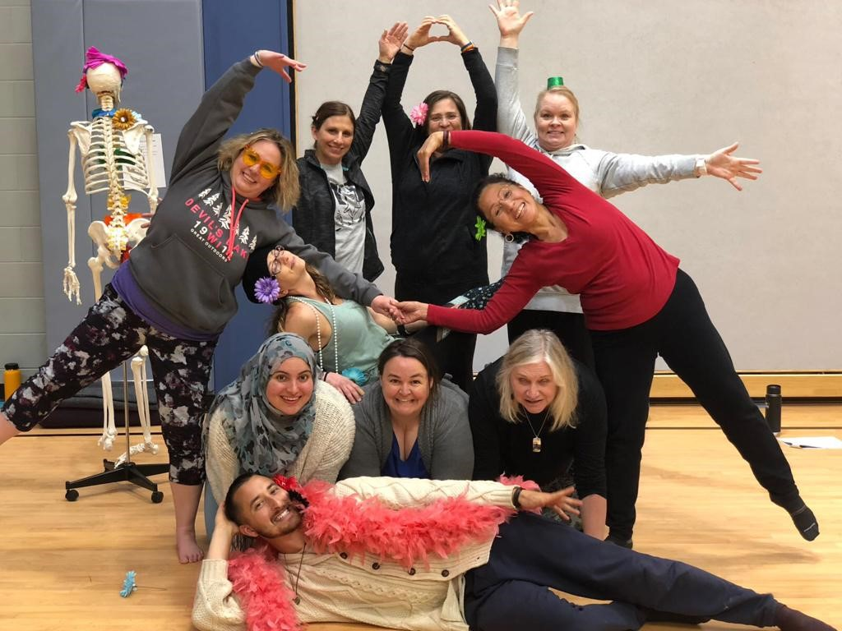

**Schedule:**

One day self-care workshop7:30am-3:30pm

**Location:** TBD

**Registration:** Edgewood College Link

**Registration Cost:** $159.00

**Registration Cost 2 or more:** $129.00

**Credits:** One or two graduate credits available for an additional $185 per credit. Credit information will be available during the workshop.

**Course Content Question:** Nisa at wiseowlwellnesswi@gmail.com

*Nisa Giaquinto* has enjoyed a career in  K-12 education as a school counseling for over 15 years. She has an M.A. in Educational Psychology from the University of Minnesota. Nisa created graduate credit wellness classes for educators in MN and currently partners with Edgewood College to offer courses. She teaches psychology courses at Madison College and is passionate about educator resiliency.



**INTENDED FOR**

Educators to include teachers, support staff, student services specialists, administrators, or any educator working with students in a K-12 setting who want to create more wellness and self-care in their daily lives. In practicing their own self-care, participants will model and implement these strategies with their students.

**OVERVIEW**

Self-care is essential to thriving and managing the intensity associated with K-12 education. In order to prevent burn out and nurture resiliency, self-care is a necessity to sustain longevity in education. Utilizing Maslow’s hierarchy of needs theoretical framework, this experiential workshop allows participants to create their own daily self-care plan and provides an opportunity to implement these strategies with their students.

**This 7-hour experiential workshop will include:**

* Mindful breathwork & mindful movement
* Journaling & intention setting
* Wellness coaching strategies including goal setting
* Creation of positive rituals and a personalized self-care plan

Course content is based on a variety of research, including work from Dr. Tina Boogen author of *Take Time for Self-Care Action Plans for Educators* and Dr. Thomas Skovholt, professor at the University of Minnesota and researcher on resiliency development and burn out prevention.

_______________________________________________________

Nisa Giaquinto has enjoyed a career in school counseling in Minnesota and Wisconsin collaborating with hundreds of educators for over 15 years. She has a master’s degree in Educational Psychology from the University of Minnesota. Nisa created a graduate credit wellness class for educators in MN and is now partnering with Edgewood College to offer courses. She currently teaches psychology courses at Madison College and is passionate about wellness psychology practices especially for educators.

Nisa Giaquinto has enjoyed a career in school counseling in Minnesota and Wisconsin collaborating with hundreds of educators for over 15 years. She has a master’s degree in Educational Psychology from the University of Minnesota. Nisa created a graduate credit wellness class for educators in MN and is now partnering with Edgewood College to offer courses. She currently teaches psychology courses at Madison College and is passionate about wellness psychology practices especially for educators.

Nisa Giaquinto has enjoyed a career in school counseling in Minnesota and Wisconsin collaborating with hundreds of educators for over 15 years. She has a master’s degree in Educational Psychology from the University of Minnesota. Nisa created a graduate credit wellness class for educators in MN and is now partnering with Edgewood College to offer courses. She currently teaches psychology courses at Madison College and is passionate about wellness psychology practices especially for educators.

**The Practice of Self-Care:** A Journey for Educators

Instructor: Nisa Giaquinto

One Day Self-Care Workshops

7:30am-3:30pm